Name Hour:
Target Marketing: Targeting More than One Market
Research 8 Markets
Below are several types of customer markets that are targeted by hotels. Hotels can target niche markets, but many do not target just one single market. They target several and use target marketing strategies to target several markets or pieces of the pie. As a result, they offer a variety of different amenities to attract several different markets to stay at their hotel.
Directions: Review the list of different target markets for hotels. Your test for this unit will be to create a hotel in a location of your choice that targets three different markets (2 customer profiles). Based on your target markets, you will offer amenities and design your property to get them to stay at your hotel. Below are 19 types of travelers that book hotels. Review the list and google the definition or brief description of each if you are not sure what it means.
You will research 8 of these types of travelers using ChatGPT. Go to ChatGPT and search eight of these listed below. For example, If I think I would want to target family travelers I would search in ChatGPT “What is the customer profile for Family Travelers for Hotels”. From the data generated, fill in each row of the table on the next three pages. In the left column, enter the name of the type of traveler. In this case “Family Travelers” as the title. In the right column fill in the bullet lists with the key details you would want to focus on for each of the 4 types of segmentation we are learning.
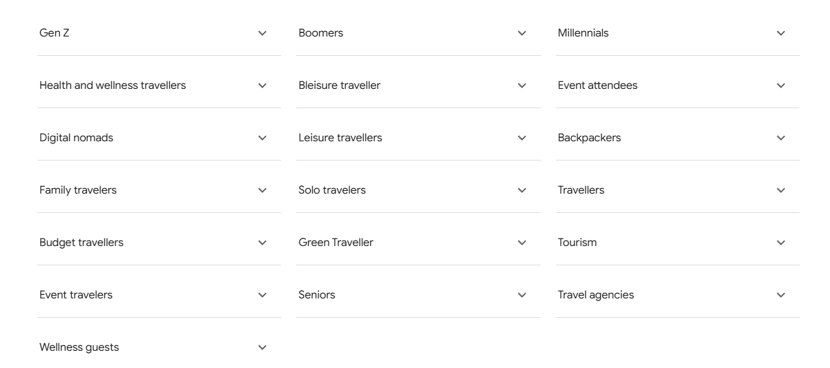

Traveler Type | What is the Customer Profile for each:
1 | Demographics  Geographics  Psychographics  Behavioral:
2 | Demographics  Geographics  Psychographics  Behavioral:
3 | Demographics  Geographics  Psychographics  Behavioral:
4 | Demographics  Geographics  Psychographics  Behavioral:
5 | Demographics  Geographics  Psychographics  Behavioral:
6 | Demographics  Geographics  Psychographics  Behavioral:
7 | Demographics  Geographics  Psychographics  Behavioral:
8 | Demographics  Geographics  Psychographics  Behavioral:

